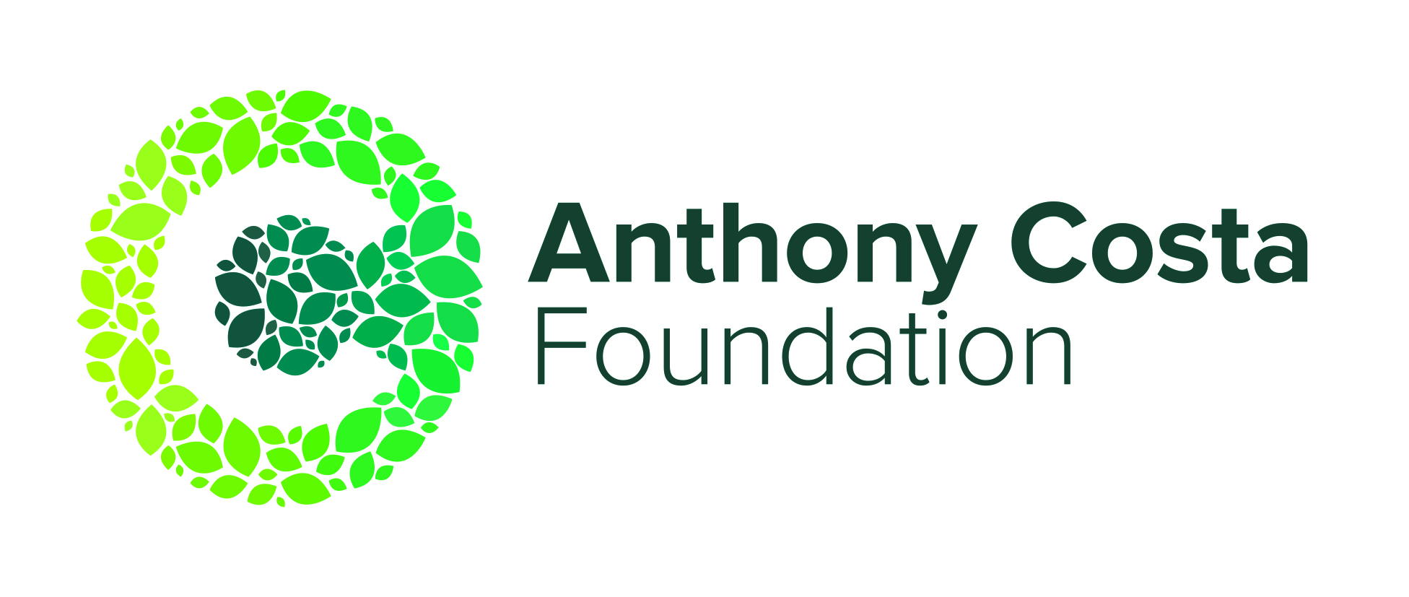
FY23 Charity Golf Day
Registration

TEAM NAME: ……………………………………………………………………...

CAPTAIN
Name | H/CAP | Email and Phone
1.

TEAM MEMBERS
Name | H/CAP | Email
2.

3.

4.

ENTRY AND OTHER FEES:
$2,000 (inc GST) for Teams of four, includes golf, breakfast, lunch and drinks. Please note limited golf carts are available for an additional fee.

Limited golf carts are available for an additional fee. Please contact Londsdale Links directly for cart reservation at 03 5258 1955. Carts will be allocated on a first in basis or for medical reasons.

PAYMENT DETAILS:
Payment can be made via cash, cheque or direct debit. Invoices can also be provided.

- Send Invoice (invoice will be sent to Team Captain)
- Direct Bank Deposit (Direct Debit Details: OCEAN MIND | BSB: 633 000 | ACCOUNT NO: 183740851 | Please reference your Team name or invoice no.)
- Cheque/Cash (please make any cheques out to “Ocean Mind”; mail or drop off at Anthony Costa Foundation, 174 Moorabool St., Geelong, VIC 3220)

TO SUBMIT ENTRIES AND ENQUIRIES:
Please email entries to foundation@costaam.com.au or mail/drop off to Anthony Costa Foundation, 174 Moorabool Street, Geelong, VIC 3220.

For enquiries or questions, please contact Cynthia Scherer E: cscherer@costaam.com.au or P: 0438 172 949.

Entries must be received by Friday 23 September 2022
benefiting

